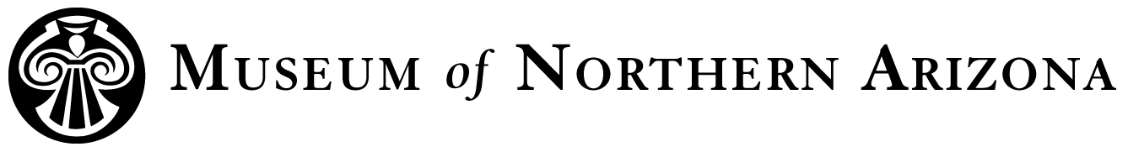
Title: Archaeologist II
Department: Anthropology
Status: Non-exempt, temporary, part-time
Supervisor: Archaeology Division Director

Position Description: Duties of the Archaeologist II include participating in survey, excavation, or site assessment; documenting cultural sites, features and artifacts; and collecting various types of archaeological data in the field. The Archaeologist II may also assist with collection and data management in the lab, as well as production of report components to meet project deliverables. Archaeologist II may occasionally supervise other positions for specific tasks in the field or lab.

Major Tasks and Responsibilities:
Field Work
- Work with MNA staff and volunteer personnel during field projects to locate, define, and assess archaeological sites and cultural features.
- Complete in-field maps, forms, and photographs of archaeological features and artifacts, including masonry and rock art, using current methods.
- Complete in-field analysis of artifacts after appropriate training.
- Interact professionally with descendant or stakeholder communities who may visit project areas or participate in field activities.

Office Work
- Complete post-field data management, including data entry and artifact analysis.
- Assist with production of reports that contain text, maps, figures, and tables based on field data, as required for project deliverables.
- Under supervision, conduct appropriate research to support field investigation.
- Interact in a professional setting with descendant or stakeholder communities to enhance research and interpretation of cultural sites and resources.
- Act as an enthusiastic advocate and personal representative for the Museum in the community by promoting its resources, programs and services.
- Other duties as assigned.

Education and Experience Requirements:
- B.A. degree in Anthropology or related field.
- At least five years of relevant experience in archaeological survey, excavation, and documentation methods, as well as data management and report production.
- Experience working with minimal supervision in field and lab settings.
- Preference will be given for experience with prehistoric and historic archaeological resources in the American Southwest or Colorado Plateau.

Abilities, Skills, and Knowledge:
- Good organizational skills and attention to detail
- Familiarity with current archaeology documentation methods, including rock art and masonry documentation, and digital photography techniques
- Familiarity with archaeological mapping techniques, including use of GPS units
- Ability to work independently as well as with MNA staff and volunteers

Working Conditions:
Work will occur in both office and field settings. Field work may involve rigorous 10-hour work days and camping in outdoor conditions with exposure to hot, cold, or inclement weather. Must be able to stand for long periods, walk 5+ miles per day, stoop and bend, lift up to 50 lbs., and handle fragile items or equipment. Field sessions will often involve being away for 4 – 8 days at a time, in areas with limited or no phone/satellite reception. Office work will occur under typical indoor conditions, usually between 8am and 5pm on Monday – Friday.

To Apply: Email a cover letter and resume to employment@musnaz.org, or call 928-774-5211 ext 203 for Human Resources for any other inquiries.

