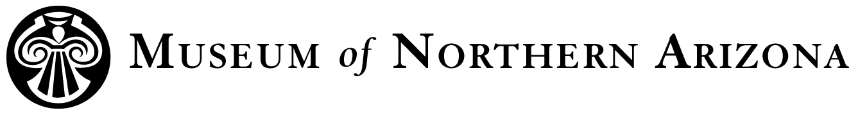

Title: Discovery Summer Camp Assistant
Department: Education
Status: Temporary, non-exempt, part-time
Supervisor: Discovery Manager

Position Description: Discovery Assistants are responsible for assisting the lead educators. They are responsible for organizing materials, clean-up, and working with the students. They are available to assist lead educator as needed.

Major Tasks and Responsibilities:
- Assist Lead Educator in developing a positive and educational environment
- Attend to the safety and educational needs of students
- Assist Lead Educator in maintaining classroom control
- Assist Lead Educator in supervising junior counselor
- Attend staff training prior to the start of camp
- Arrive at least 15 minutes prior to start of class and stay 15 minutes after daily
- Must assist Lead Educator in thorough classroom cleaning at the end of the class

Education and experience requirements:
- High school diploma, AA degree; preferred but not required
- Possesses a valid driver’s license and clean driving record
- Must be at least 21 years of age to drive per insurance regulations
- Ability to obtain First Aid/CPR certifications prior to the class start date
- Experience developing or assisting in educational programming preferred, but not required

Abilities, Skills, and Knowledge:
- Must have experience with equipment related to class
- Must be able to relay directions clearly and concisely
- Must be able to supervise and work well with others
- Attention to detail
- Ability to communicate with others

Working conditions: Generally indoors and outdoors, Monday through Friday unless otherwise specified.

Must be able to lift 20 pounds, walk moderate distances, and work well with others

Job contingent on satisfactory passing a background security check

To apply, send a cover letter, resume, and three references to Jill Thomas at jthomas@musnaz.org.
Email is the preferred method of application submission. If you are not able to submit your application via email, please call Jill Thomas at 928-774-5211, Ext. 203 to receive additional instructions for application submission.
Deadline for application materials: February 25, 2019

Position starts: June 10, 2019
Position ends: Aug. 2, 2019

The Museum of Northern Arizona is an Equal Opportunity Employer.

