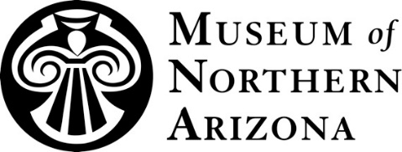

PROGRAM ADVISORY

Program: Sedona Muses Lecture Series: Colorado Plateau Extremes
Dates: January 9 – April 10, 2017
Location: Sedona United Methodist Church, 110 Indian Cliffs Road, Sedona, Arizona 86336

PRESS CONTACT Cristen Crujido, Marketing Director, ccrujido@musnaz.org, 928.774.5211, ext. 273

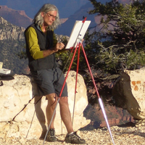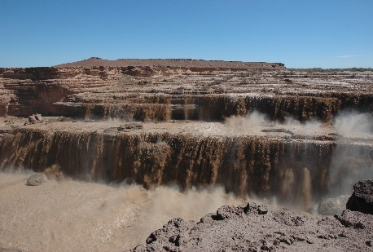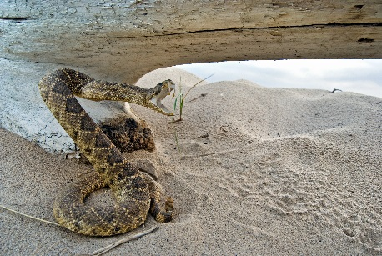

Sedona Muses, Museum of Northern Arizona Present
Colorado Plateau Extremes Starting January 9
(Flagstaff, Ariz.) December 19, 2016 – Join artists and scientists for informative and insightful discussions when the Sedona Muses of the Museum of Northern Arizona (MNA) presents “Colorado Plateau Extremes,” an annual monthly lecture series beginning January 9. The lecture series runs the second Monday of the each month from January through April at the Sedona United Methodist Church, 110 Indian Cliffs Road, and begins at 7:00 p.m. Tickets, $6 for MNA and Sedona Muses members and $7 for nonmembers, are available for purchase at Bashas’ in Sedona, Weber’s IGA at the Village of Oak Creek, or at the door beginning at 6:30 p.m. the evening of the event.
“This series is a wonderful opportunity for the public to learn more about the art, culture and natural history of the Colorado Plateau,” said Sedona Muses board member Rebecca DeVault. “This season’s presenters will share unforgettable stories and insight into the region’s most extreme terrain, geological wonders, species and adventurers.
Flagstaff painter Bruce Aiken opens the series with “Extreme Art” on Monday, January 9. For more than 30 years, Aiken lived within the Grand Canyon, producing hundreds of paintings, drawings and pastels capturing its beauty. Attendees will hear stories of the artist painting in the Canyon depths and in other remote areas of the world, including Mount Everest.
To learn more about the Sedona Muses lecture series, visit musnaz.org or call 928.774.5213.
2017 Lecture Schedule

January 9
Extreme Art with Bruce Aiken
Flagstaff painter shares stories of creating in one of the natural wonders of the world–Grand Canyon.
For more than 30 years, Aiken lived within the Canyon, producing hundreds of paintings, drawings, and pastels documenting its beauty. Join the artist as he discusses creating in the Canyon depths as well as other remote areas of the world, including Mount Everest.

--MORE--

February 13
Extreme Explosions with Dr. Kent Colbath
Within the past few million years volcanism has begun encroaching on the southern rim of the Colorado Plateau. Join geologist Dr. Kent Colbath as he discusses the young volcanic fields of the region and the prospects for eruptions in the future.

March 13
Plateau Extremophilia: Surviving Nature's Worst-case Scenarios with Dr. Larry Stevens
How do plants and animals survive floods, fire, and other natural disasters that deeply challenge life? The Museum's Curator of Ecology, Dr. Larry Stevens, will describe and discuss the wide array of Colorado Plateau "extremophiles," life forms that are adapted to, and even require, severe environmental conditions.

April 10
Extreme Landscapes with Wayne Ranney
Award-winning author and geologic interpreter Wayne Ranney documents his most recent adventures through a photographic tour of the earth's most incredible terrain, including the American Southwest.

***

The Museum of Northern Arizona inspires a sense of love and responsibility for the beauty and diversity of the Colorado Plateau. Founded in 1928, the Museum includes an historic exhibit building with nine galleries showcasing the geology, anthropology and art of the region; research and collections facilities; a museum shop and bookstore; and more than 450 public programs annually. To learn more, visit musnaz.org or call (928) 774-5213.

