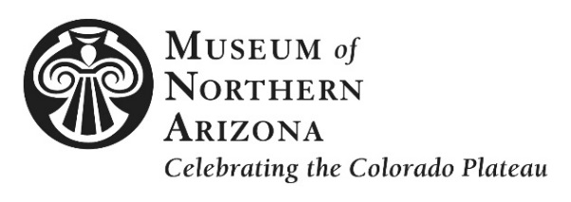

PRESS RELEASE

CONTACT Cristen Crujido, Marketing Director
ccrujido@musnaz.org, 928.774.5211, ext. 273

MNA Announces Winners of the 67th Annual Navajo Festival of Arts & Culture

(Flagstaff, Ariz.) August 8, 2016 – The Museum of Northern Arizona (MNA) is pleased to announce the winners of the 67th Annual Navajo Festival of Arts & Culture juried award competition. Twelve artists received ribbons in eight categories at the event, held August 6-7 at MNA.

Best of Show
Sponsored by Medicine Man Gallery
Classic Sarape Poncho - TahNibaa Naataanii

MNA Spirit Award
Blue World - Elizabeth Whitethorne-Benally

2D Fine Art
1st Place: Fingerprint Umbrella - Elizabeth Whitethorne-Benally
2nd Place: Sunshine on a Cloudy Day - Beverly Blacksheep
Honorable Mention: Warriors Gaze - Bahe Whitethorne, Jr.
Honorable Mention: Sacred Rhythms - Peterson Yazzie

Cultural Arts
Sponsored by First American Art Magazine
1st Place: Gourd Yeti - Steven A. Darden
2nd Place: Hand Beaded Wall Weaving - Kim Lohnes
Honorable Mention: Traditional Rattle - Steven A. Darden

Jewelry
1st Place: Traditional & Contemporary Comet Design Bolo - Abraham Begay
2nd Place: Navajo Warrior Pendant/Pin - Vernon Begaye
Honorable Mention: Contemporary Bracelet - Abraham Begay

Sculpture
Honorable Mention: Yei` (Healing) with Eagle - Roy M. Walters

Textiles — Weaving
1st Place: Classic Sarape Poncho - TahNibaa Naataanii
2nd Place: Regional Traditional Crystal Weaving with Checkered Background - Mona Laughing
Honorable Mention: Regional Traditional Crystal Weaving with Vegetable & Natural Dyes - Mona Laughing

Youth
1st Place: Kitty Couple - Rachel Wilson
2nd Place: Red Kitty - Rachel Wilson

###

