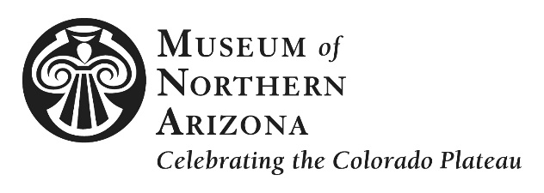

PRESS RELEASE

MEDIA CONTACT Marketing & PR Department, marketing@musnaz.org, 928.774.5211, ext. 273

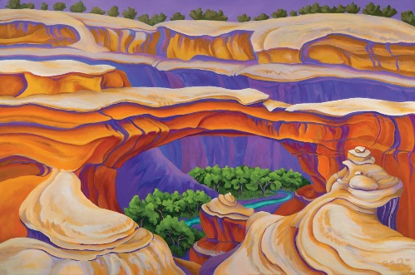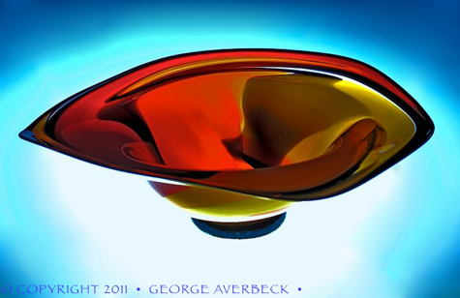

Confluence of Color opens Feb. 17
Exhibition celebrates rich hues, forms inspired by the Colorado Plateau

(Flagstaff, Ariz.) December 5, 2017 – More than 40 works by glass artist George Averbeck and painter Serena Supplee will be on view when the Museum of Northern Arizona (MNA) mounts its spring exhibition, Confluence of Color: George Averbeck & Serena Supplee opening Saturday, February 17, 2018, in the Museum’s Donald Ware Waddell Gallery. The exhibition is on view through May 28. A gallery talk with the artists and Alan Petersen, MNA Curator of Fine Art, is scheduled at 2 p.m. and is free with Museum admission or membership.

Confluence of Color features vibrant sculptural glass and oil works by these renowned Southwest artists, celebrating the natural forms and saturated desert hues of the varied landscapes of the Colorado Plateau.

Originally from Iowa, Supplee earned her Bachelor of Fine Arts at Northern Arizona University (NAU), before moving to Moab, UT. Her love affair with the Colorado Plateau began when she first saw it as a teenager, and after graduation she spent 10 years as a river guide on the Colorado, Green and San Juan Rivers. Supplee often paints en plein aire, capturing the Plateau’s ever-changing light and landscape in watercolor which she then transforms into larger oils. Her work reveals her depth of intimacy with this landscape. Her work has been featured in more than 50 one-woman shows throughout the Southwest and her popular notecards, posters and postcards are favorites of visitors worldwide.

Like Supplee, Averbeck’s fascination with the Colorado Plateau began on a family trip. Then, in the early 1970s, he developed an affinity for glass blowing, having previously worked in metal and jewelry. After attending NAU as well as the prestigious Penland School of Crafts in N.C., he worked for glass artist Kerry Feldman, Fineline Studios in Breckenridge, Color. and later at his own Fire on the Mountain Gallery in Flagstaff. He is best known for his colorful platters and Datura vases.

Averbeck and Supplee have been friends and artistic collaborators for thirty years. Throughout this time, they have often been inspired by each other’s creations. This relationship results in a shared aesthetic of rich color and a similar lexicon of forms, defining elements of each artists’ instantly recognizable style.

“We are thrilled to showcase the work of Averbeck and Supplee,” said Petersen. “This exhibition will immerse visitors in a magical environment that illuminates the unique and inspiring landscapes of the Colorado Plateau and its influence on shaping the oeuvre of each artist.”

--MORE--

A member preview will be held Friday, February 16, from 6 p.m. to 8 p.m., and includes a wine and hors d’oeuvres reception and artist meet and greet. To become a member, call (928) 774-5211, ext. 219.

The Museum of Northern Arizona is located at 3101 N. Fort Valley Road in Flagstaff, Ariz. To learn more, visit musnaz.org or call 928.774.5213.

###

The Museum of Northern Arizona inspires a sense of love and responsibility for the beauty and diversity of the Colorado Plateau. Founded in 1928, the 200-acre campus includes an historic exhibit building with nine galleries showcasing the geology, anthropology and art of the region; research and collections facilities; a museum shop and bookstore; and more than 450 public programs annually. To learn more, visit musnaz.org or call 928.774.5213.

Location: Museum of Northern Arizona, 3101 N. Fort Valley Rd, Flagstaff, Ariz. 86001
Phone & Website: 928.774.5213, musnaz.org

Images: High resolution images are available upon request.
(L) Bridging Naturally by Serena Supplee, 2014, oil on canvas, 36 x 54 inches.
(R) Blown Glass Bowl by George Averbeck, 2011.

