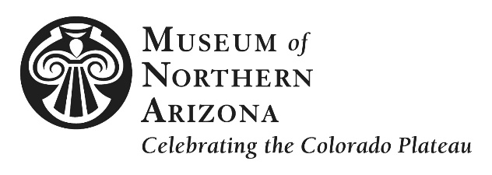

PRESS RELEASE

CONTACT Cristen Crujido, Marketing Director, ccrujido@musnaz.org, 928.774.5211, ext. 273

Happy Birthday Discovery
MNA celebrates program’s 40th birthday with inaugural Youth Fest

(Flagstaff, Ariz.) April 11, 2016 – Children of all ages are invited to join the Museum of Northern Arizona (MNA) at its inaugural Youth Fest Saturday, May 14, from 10 a.m. – 5 p.m. MNA is located at 3101 N. Fort Valley Road in Flagstaff. Ticket prices are $12 adult and $8 student (with ID), American Indian (10+ with tribal affiliation) and youth 10-17. Children under 10, members and teachers (with ID) are free.

Programmed in celebration of the 40th birthday of MNA’s Discovery Program, the multi-cultural event celebrates children from across the Colorado Plateau through music, dance, storytelling and the visual arts. Attendees will experience the artistry of the Hopi Canyon Warriors, Pinon Dancers and Ballet Folklorico de Colores while enjoying storytelling, face-painting and arts and crafts. In addition, guests will enjoy the opening of two new exhibitions: When We Were Young: The Legacy of MNA’s Junior Indian Art Show featuring past and more recent work by noted Native American artists, as well as a photo exhibit of Zuni, Hopi, Navajo and Latino Heritage Festival youth performers.

“This event is an opportunity for northern Arizona youth to share their cultures and talents with visiting audiences,” said Carrie M. Heinonen, CEO and the Robert Breunig Director of MNA. “It will be a wonderful day of cross-cultural exchange.”

At 3:00 p.m. free cake and ice cream will be served in the Museum’s Jaime Major Golightly Courtyard to event guests. Community members are invited to help celebrate and share 40 years of Discovery memories.

The event is sponsored by Around the Mountain Pediatric Dentistry with additional support provided by Flagstaff Public Library and KUYI Hopi Radio. Vendors and participating organizations include: Carry the Future, Flagstaff Youth Powwow Dancers, Grand Canyon Wolf Recovery Project and Salina Bookshelf, Inc. Former Discovery program attendees are invited to share photographs or memories for display by emailing jglennon@musnaz.org.

For more information, including a complete list of scheduled performances, visit musnaz.org. Information is also available by phone at (928) 774-5213.

***

The Museum of Northern Arizona inspires a sense of love and responsibility for the beauty and diversity of the Colorado Plateau. Founded in 1928, the 200-acre campus includes an historic exhibit building with nine galleries showcasing the geology, anthropology and art of the region; research and collections facilities; a museum shop and bookstore; and more than 450 public programs annually. To learn more, visit musnaz.org or call (928) 774-5213.

Location: Museum of Northern Arizona, 3101 N. Fort Valley Rd, Flagstaff, AZ 86001
Phone & Website 928.774.5213, musnaz.org
Connect with MNA @museumofnaz #museumofnaz

