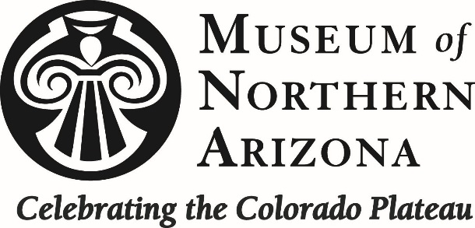
Title: Administrative Assistant for Ecology
Department: Ecology and Conservation
Status: Non Exempt, Part-time, Hourly, Temporary, Project-Specific
Supervisor: Jeri Ledbetter – Springs Stewardship Institute Program Manager

Background: The Ecology and Conservation research department conducts research on the ecosystems, flora, and fauna of the Colorado Plateau. The Springs Stewardship Institute (SSI) is a global initiative of the Museum of Northern Arizona. SSI was established to improve our understanding of springs ecology, to educate the public and resource managers about the importance of springs stewardship, and to partner with other organizations, agencies, tribes, and researchers who are working to protect these important and highly threatened ecosystems.

Position Description:
This position requires a hard-working, motivated individual with: excellent computer and organizational skills; experience with bookkeeping and information management; and an interest in resource management, ecosystem ecology, and biological sciences for an administrative assistant position. We are looking for someone who is passionate about natural resources, and comfortable working both with others as well as independently. The position is primarily office-based, but may occasionally involve fieldwork, some of it rigorous. This employee should be able to work independently, but readily seek guidance and look forward to learning new skills. Responsibilities will include (but are not limited to):
- Project planning and logistics including tasks, deadlines, and requirements
- Developing, writing, and reviewing project interim and final reports
- Bookkeeping, expense tracking, budgeting, and payroll approval
- Office administrative and organizational tasks
- Data entry, information management, and quality control
- Website design and maintenance
- Volunteer, staff, and subcontractor coordination
- Proposal research, planning, and writing

Requirements:
- Degree in information management, accounting, natural science, and/or experience in a related field
- Experience with bookkeeping, expense tracking, and budgeting
- Excellent written and verbal communication skills
- Well-organized and detail-oriented
- Possession of a strong work ethic and the ability to work independently and solve problems
- At times the position may involve field work, so applicant should be physically fit
Desired Qualifications:
- Experience working with Adobe and GIS software
- Familiar with the Colorado Plateau region
- Understanding of basic accounting practices
- Experience with invertebrate identification and curation

Benefits and Compensation:
- Membership to the Museum of Northern Arizona
- Hourly wage commensurate with experience and project-specific funding
- Experience working with a local non-profit with a global focus
- Experience working with invertebrate identification and curation
- Potential for 40 hours and pay advancement

To Apply:
Please submit a cover letter and resume to employment@musnaz.org. For more information about MNA Ecology, visit https://musnaz.org/research/ecology-and-conservation/. For information about SSI, visit http://springstewardshipinstitute.org/ and our online database at http://springsdata.org/.

