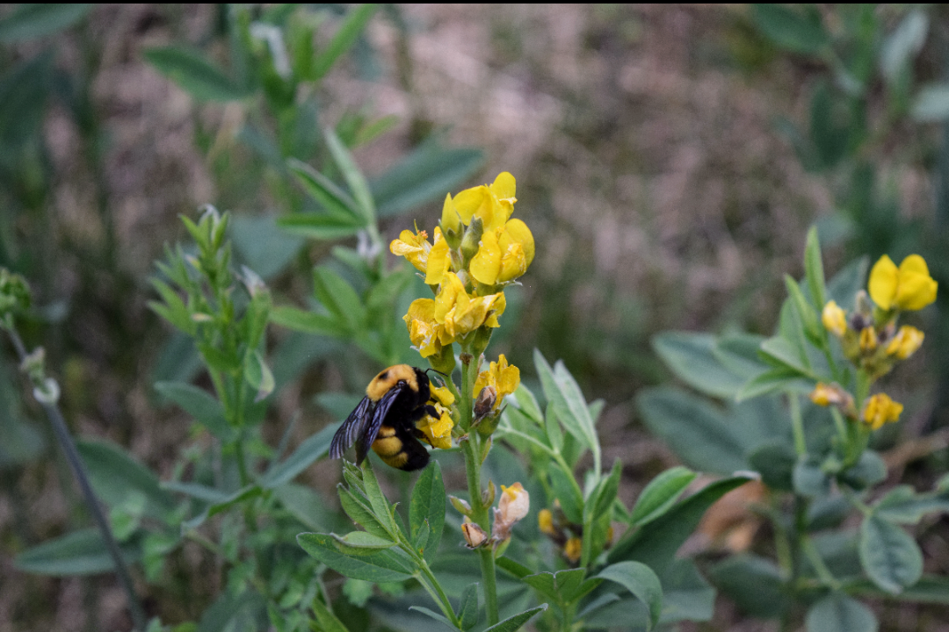  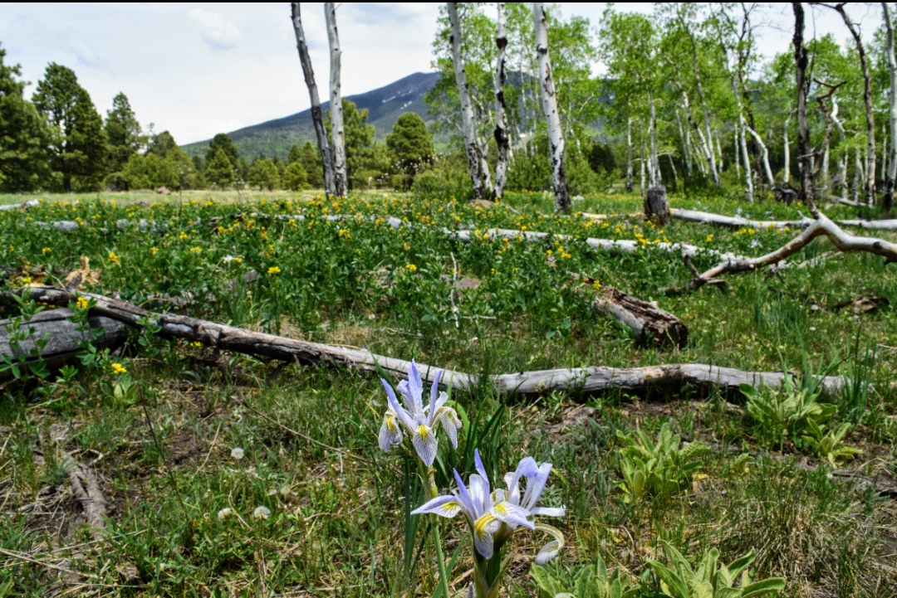  Photos by Lorie Cavalli  Bebb’s Willow Community  Hart Prairie has the largest Bebb’s Willow tree population in the world. It is maintained by the Nature Conservatory. Bebb’s Willows are usually between 10 and 25 feet tall. Their leaves are elliptical and become smooth over time. Their bark either has a reddish, olive green, or gray tint and it is usually thin. They also have shallow and dense roots. Bebb’s Willow attracts animals like deer, elk, and rabbits. It also helps reduce stream bank erosion and protect aquatic environments. | Wildflowers  Hart Prairie is home to many different types of wildflowers including:  - Wild Iris: The most common Wild Iris are Blur Flags. These Irises are best suited in wetter environments and are usually cross pollinated by bees.  - Lamb's Ear: This herb is covered in dense silk like hair. It had a tall spike stem with few leaves. It produces small purple flowers during the spring  - Skyrocket Penstemon: This flower blooms during the summer and attracts hummingbirds and hawk moths. These flowers do best in dry forest like environments with sun.  - Prairie Smoke: This semi rare plant is part of the rose family and can be used for medical purposes. It starts to bloom around late spring.  - Sneezeweed: These flowers are apart of the daisy family and attract bees and butterflies. These flowers need wet soil and full sun. This flower has larger pollen grains that get spread by insects not wind.  - Arizona Fescue: This native grass stand from 1 to 3 feet tall and has a deep, dense, root system. It cannot withstand foot traffic.  - Wild Rose: This flower is usually in bloom from spring to early summer. Birds and insects help pollenate.  - Native Thistle: These flowers are apart of the sunflower family and are becoming rarer as time passes. | Photo by Lorie Cavalli  Hart Prairie
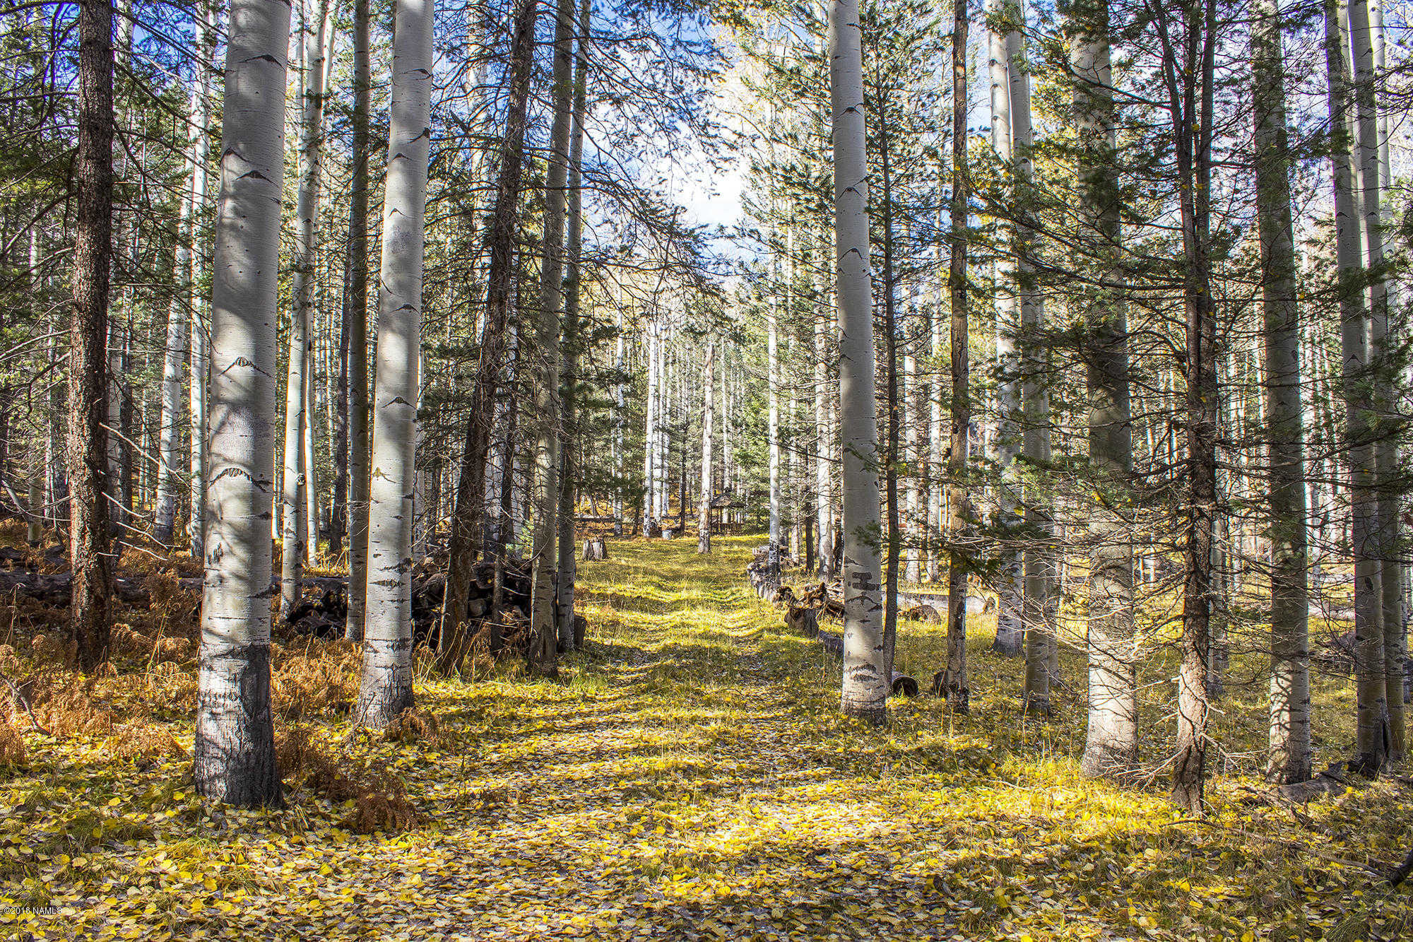  Aspens  Aspens are white barked trees that leaves turn a golden color in the fall. Animals such as deer and woodpeckers like to call these trees home. These trees have lush understories that make it hard for the trees to burn. Even if the overstory of the trees burn down the roots will spore more seeds to regrow the trees. Aspen’s roots grow in a massive system and can survive for thousands of years, even through the trees can only live between 80 and 120 years. | Cows  While hiking you can spot cows openly grazing on the prairie.  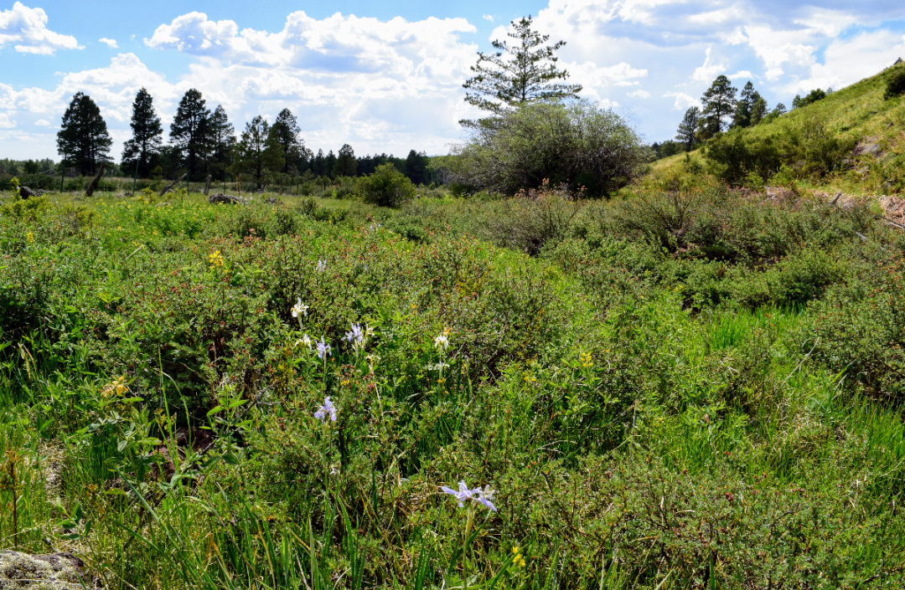  *Wildlife  - Brown Bears: Although they are normally depicted as nocturnal, Brown Bears are often awake during morning and early evening hours. These bears do not fully hibernate and can be woken easily during the winter. Adult males and females with cubs are the more aggressive types.  - Raptors: Also known as birds of prey, are birds that hunt vertebrates. They have sharp eyes to track prey, strong talons, and curved beaks. | 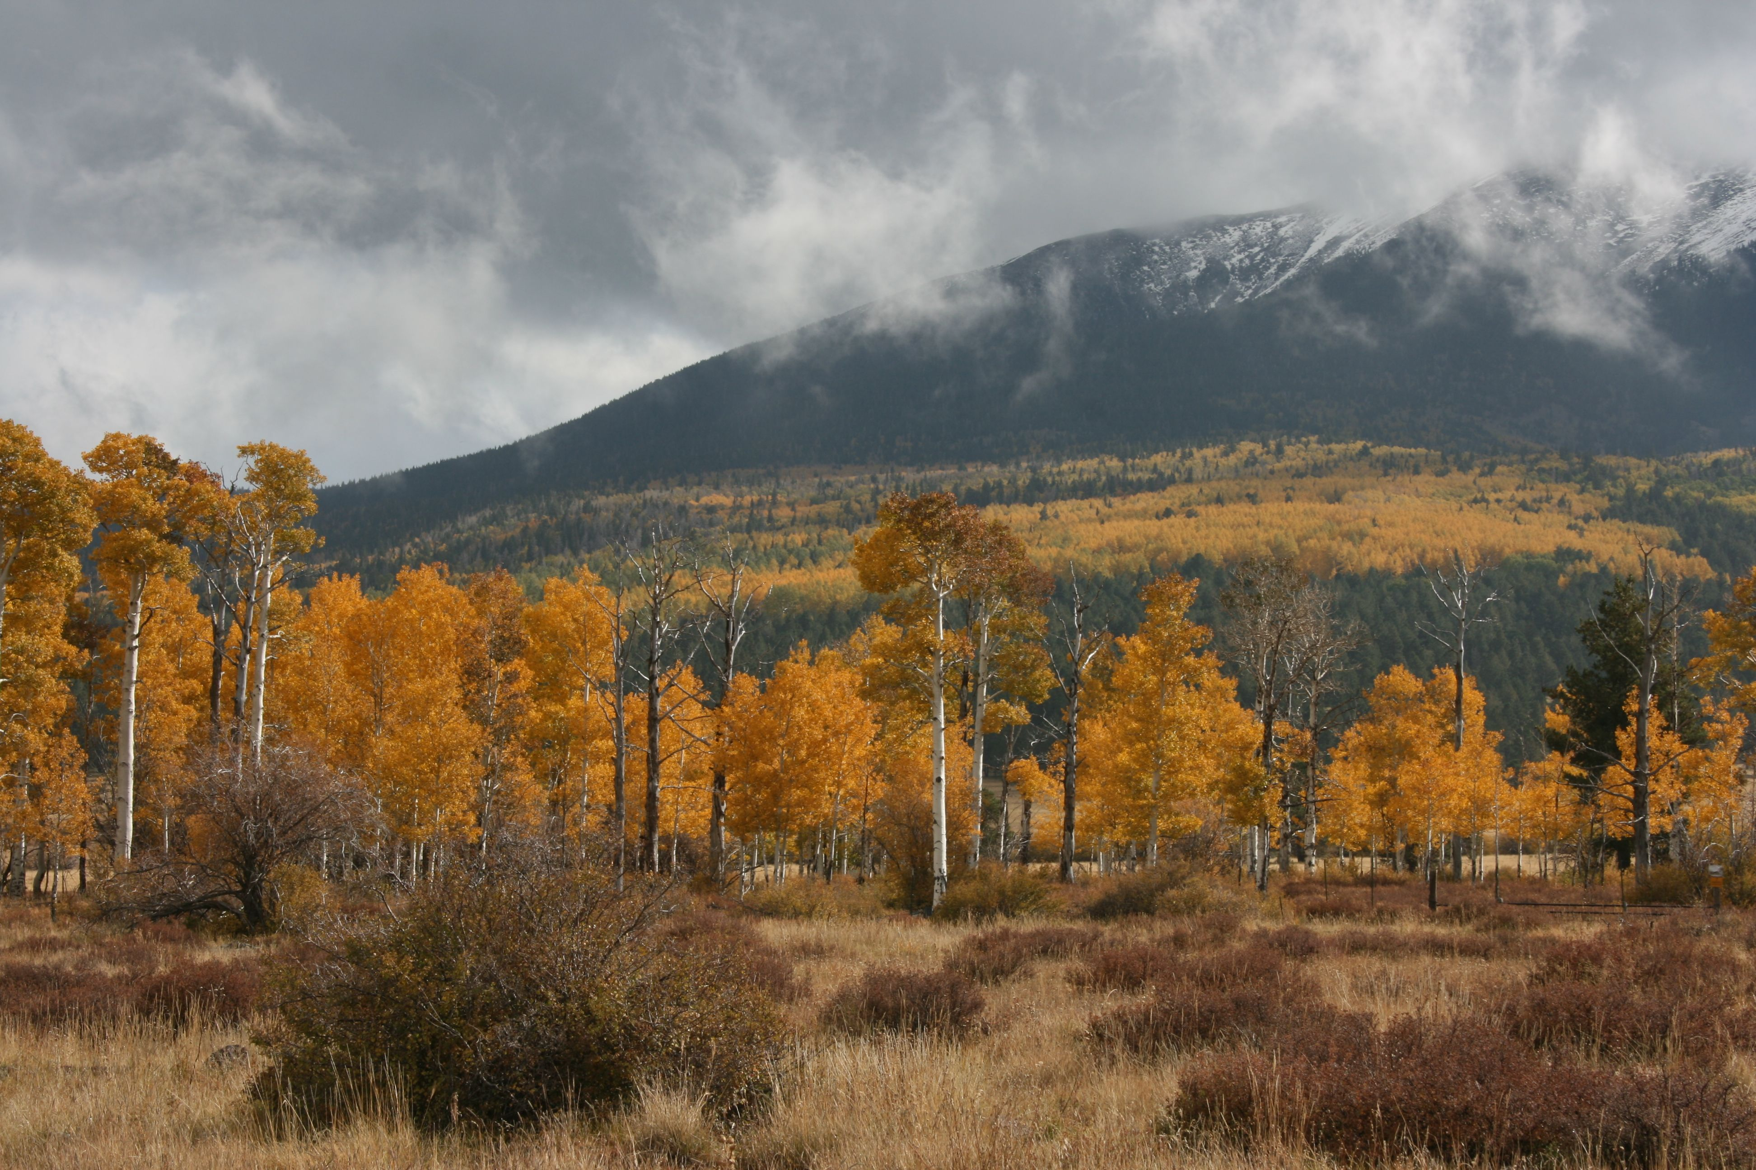  Galinas Tanks  Galinas Tank is a manmade water tank and important for wildlife. Animals such as elk and deer would benefit from the tank. When visiting Galinas Tank notice the plants around the tank. Are there any similarities or difference from ones in the meadow?  Go Explore!  Link to places you can hike and explore in Hart Prairie  https://hikearizona.com/decoder.php?ZTN=952  *Riparian Pic Photo by Lorie Cavalli

