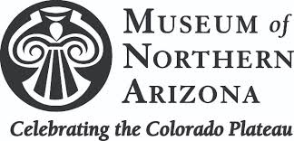

Make Earth Pops
We will learn about the Earth by making an edible model to represent the four layers of the Earth: the crust on the outside, the mantel and the core-split between the outer and inner core. Watch the Family Friday video June 5 for instructions.

Materials
1 red jelly belly (cinnamon would be a good flavor)
This will be the inner and outer core
1 BIG marshmallow for the Mantel.
The Mantel is 84% of the Earth’s volume, so don’t use little marshmallows
4 crushed Oreo cookies (just the cookie part)
1 popsicle stick

Vocabulary words:
Geology: Geology is the study of rocks and other non-living things that make up the planet Earth

Rock Families: Geologist classify rocks into three basic groups based on how they were formed in nature.
The types of rocks are igneous, sedimentary and metamorphic.

Earth Crust: The Earth's crust is the outermost layer of our planet; it's a thin shell that surrounds the entire Earth and is the part we live on

Mantle: The Earth’s mantle lies between the crust and the outer core of our planet. The mantle is mostly solid rock but parts are hotter and more fluid.

Outer Core: The outer core is the outer layer of the core that is made of liquid iron and nickel. Since it is a liquid, the outer core can spin, and it does.

Inner Core: The inner core is the deepest and hottest layer of our planet. It is solid rock made up of iron and nickel

