14th Annual
“To Go” GALA
Benefiting the Museum of Northern Arizona
Sponsorship Levels
Gala To Go Dinner & Auction: Saturday, August 29th 2020

Mesa Verde Sponsor
$5,000 (Tax Deductible Amount $4,160)

Benefits Include:
- “To Go” package for 10 of your closest friends or family, including 10 certificates with this sponsorship
    - 10 certificates to Josephine’s Bistro – 10 homemade masks by Hopi Seamstress – Dessert – Plateau Magazine – artist notecards
- Curator-led tour of exhibit at a later date and time for up to 10 guests
- 2 Museum Open Access Corporate Cards and 10 Museum guest passes
OR 4 Painted Desert level MNA Gift Memberships
- Name or company logo and URL link on MNA’s website for approximately 6 months
- Listing in Arizona Daily Sun thank you ad
- Listing in and all Gala weekend promotions
- “Sponsor Spotlight” feature in social media posts and MNA e-newsletter

Kaibab Vista Sponsor – Gala Dinner
$3,000 (Tax Deductible Amount $2,400)

Benefits Include:
- “To Go” package including
    - 8 certificates to Josephine’s Bistro – 8 homemade masks by Hopi Seamstress – Dessert – Plateau Magazine – artist notecards
- Name or company name & URL link on MNA’s website for approximately 6 months
- Listing in Arizona Daily Sun thank you ad
- Listing in event program and select gala collateral

Contact Information
Liz McGinlay at LMcGinlay@musnaz.org or 928.774.5211 ext. 227

Note
Individual tickets for the August 29th Gala To Go Dinner are available for $300 per person.
Individual “online only” tickets are available for $50 per person.
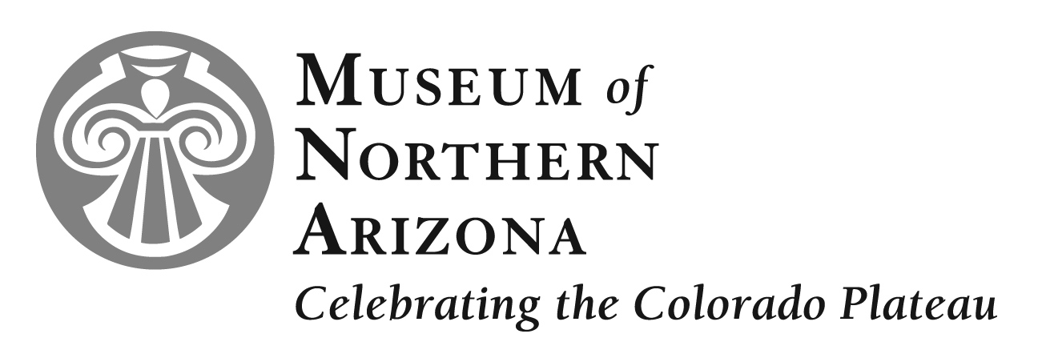
Click here for more information www.musnaz.org/gala

