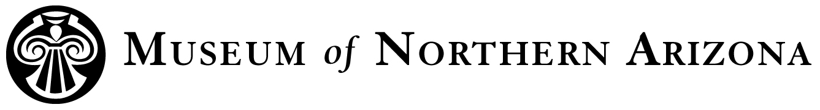

**Title**: Collections Associate

**Department**: Collections

**Status**: Project Specific, Part-Time, 10 to 20 hours per week - not to exceed 29 hours per week

**Co-supervisors**: MNA Collections Director and NPS Museum Curator

**Position Description:** National Park Service (NPS)-funded position to catalog, inventory, and re-house NPS objects, specimens, and archives.

**Major Tasks and Responsibilities:**

* Rehouse and catalog over 10 boxes of archaeological and historical objects from Canyon de Chelly.
* Help move fine arts collections into new storage units.
* Hand-write consistent archival folder headings.
* Enter Northern Arizona University data into ICMS and Argus databases for Navajo National Monument faunal bones.
* Make corrections to accession folders.
* Create buffered spacers for archives sagging in boxes and remove staples and paper clips from archives.
* Rehouse archives in large boxes on tops of shelves into smaller boxes and mark box labels with location information.
* Rehouse prints in large binders into smaller O-ring binders.
* Help move historic furnishings from Curator’s office into Ranger Cabin at Walnut Canyon.
* Help move rolled archival maps into flat storage map drawers and update the ICMS database.
* Assist with locating NPS items on 2022 random sample annual inventories and on Walnut Canyon and Wupatki missing items list.
* Other related tasks as assigned.

**Education and Experience Requirements**:

College coursework in Southwestern anthropology, archaeology, archives, history and/or indigenous studies. Prior museum collections experience preferred.

**Abilities, Skills, and Knowledge:**

* Demonstrated ability to communicate well orally
* Good organizational skills
* Excellent attention to detail
* Legible handwriting
* Ability to correct data discrepancies
* Familiarity with computer databases, spreadsheets, and word processing
* Ability to work independently as well as cooperatively with other Collections Associates and supervisors

**Working Conditions**: Generally, work indoors for 10 to 20 hours a week (no more than 29 hours per week), usually between 9 am and 5 pm. Odd hours and long days may occasionally be required. Must be able to sit for long periods, stoop and bend, lift up to 50 lbs, and handle fragile items.

**Other Requirements:** Applicant must have good eyesight (with contacts or glasses is acceptable) and show proof of full COVID-19 vaccination status.

**Job contingent on satisfactory passing of MNA background security check. The chosen applicant will also need to undergo an NPS background check before permitted use of a government computer.**

_______________________________________________________________________

**Salary**: $15.50 per hour

**How To apply**:  
Please submit a cover letter, resume, and three professional references to Jill Thomas at employment@musnaz.org.  
  
Email is the preferred method of application submission. If you are not able to submit your application via email, please call Jill Thomas at 928-774-5211, Ext. 203 to receive additional instructions for application submission.

**Deadline:**

The position begins the week of January 10, 2022.

The Museum of Northern Arizona is an EEO employer.